### UE20CS301

## Database Management System

## Lab 4 – Task II Results

Name : Renita Kurian

SRN : PES1UG20CS331

Roll No. : 13

Create User:

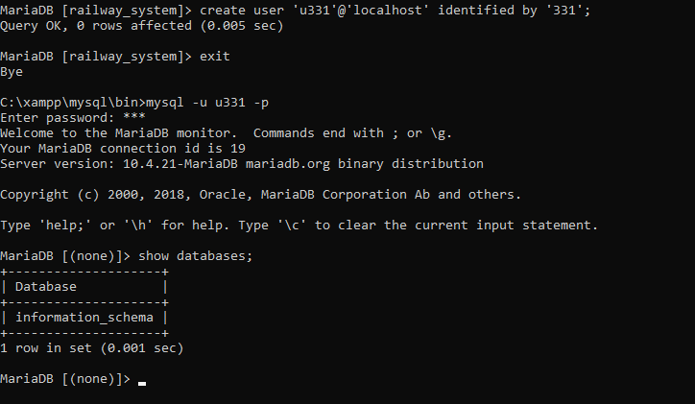

1. Grant privileges

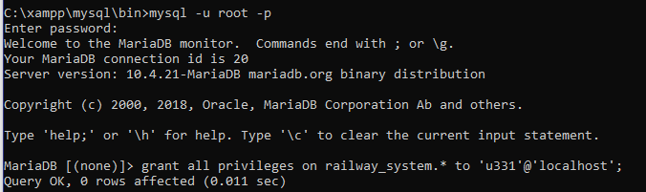

-- railway_system database present after executing grant command

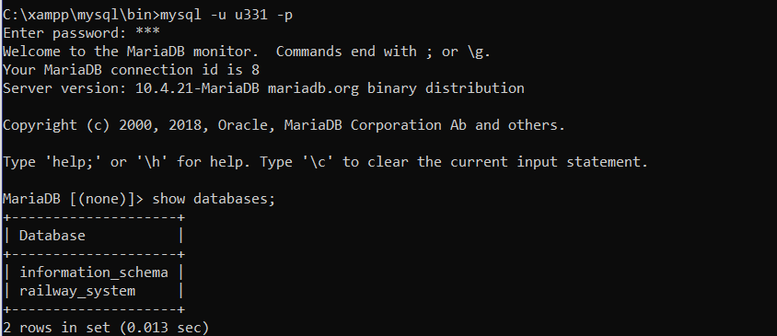

2. Revoke update and delete

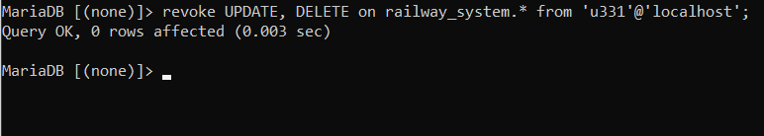

After revoke –

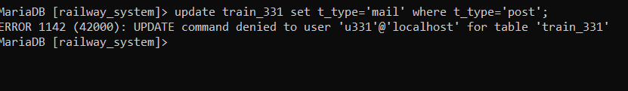

3. Create different savepoints

i) Create a savepoint

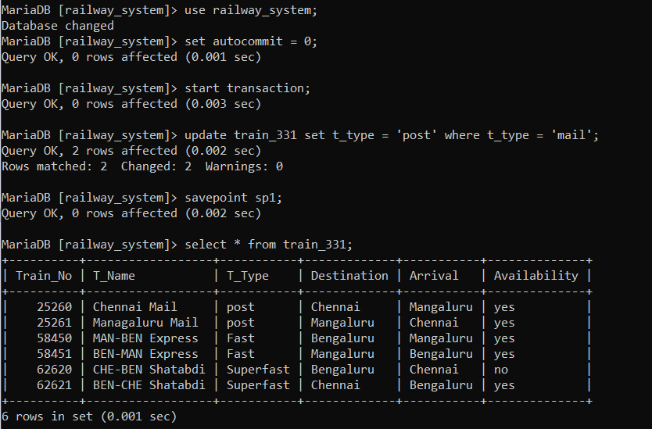

ii)Rollback

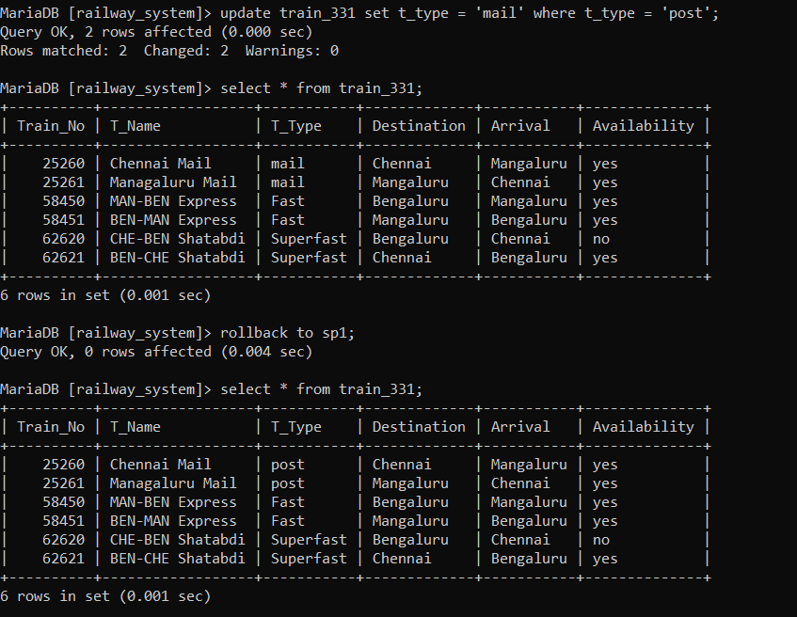

iii) Commit

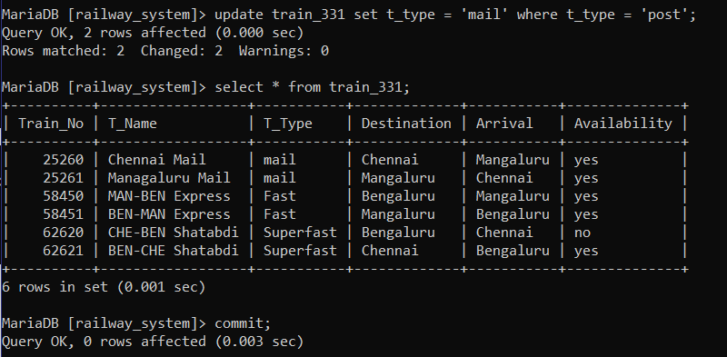

iv) Release

